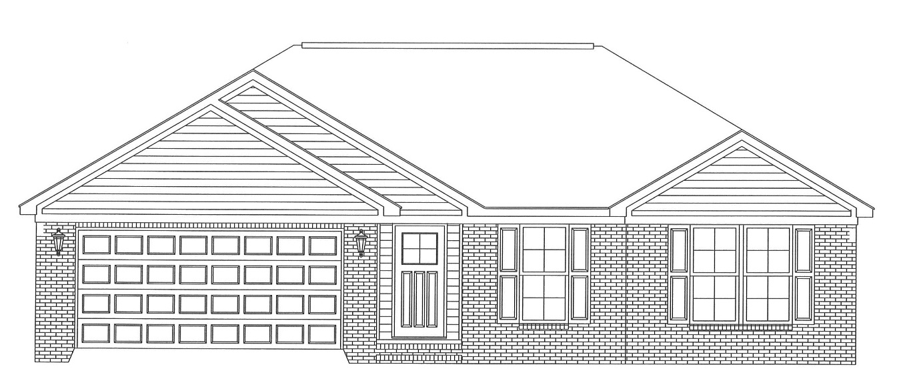

112 Sugarberry Road
$173,500

Pine Lake Subdivision

1,707 Square Feet
3 Bedrooms / 2 Baths

Pine Lake is a GREAT neighborhood for your family that provides affordable homes. This neighborhood features all brick homes and a neighborhood lake that your family will enjoy. 112 Sugarberry will prove the value of Pine Lake. This home features:

- Low Maintenance Brick Exterior
- Open, Split Floor Plan
- Walk-in Storage Closet off Entry
- Sizable Laundry
- Stainless Steel Appliances
- Kitchen Island and Pantry

- Rear Covered Patio
- Private Master Suite featuring His and Her Sinks with Linen Cabinet, Compartmented Water Closet and Spacious Walk-In Closet

*Square footage is approximate. Plans, features and price are all subject to change. *

112 Sugarberry Road

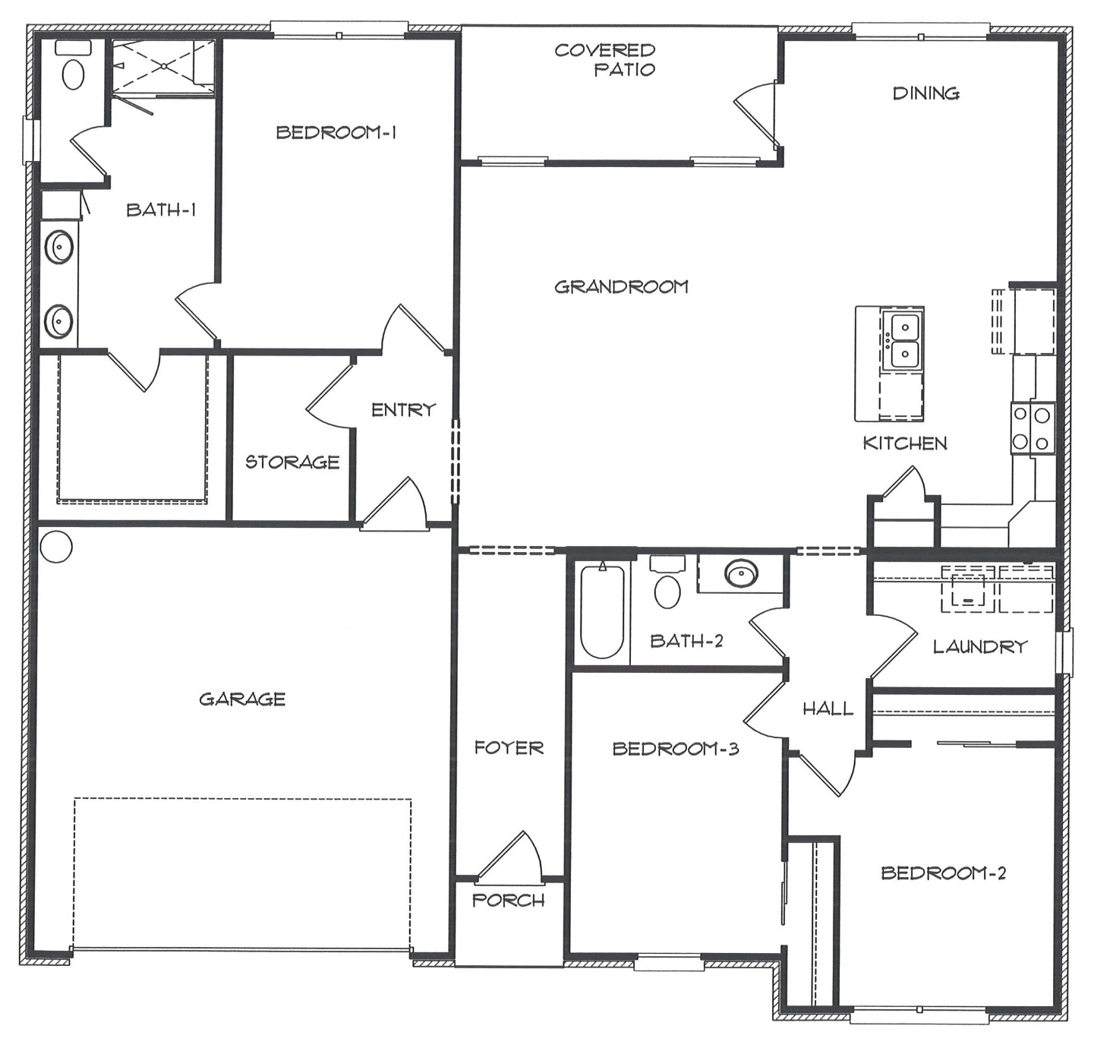

Over 60 years ago, Alfred Saliba Corporation (ASC) started as a family home building business. Today, our family has grown into a corporation, but we still hold fast to the basic principles Alfred Saliba held so dearly. We believe in service to the community, great service to our customers and excellence in everything we do. Because of these principles, our corporation has an outstanding reputation throughout the Wiregrass. ASC has a team of employees working to make your home buying experience one of the best.

